Table: **"StudentCourses"**

Imagine you have been given a table named "StudentCourses" that contains information about students and the courses they are enrolled in. Analyze the table, identify normalization issues, and then proceed to normalize it.

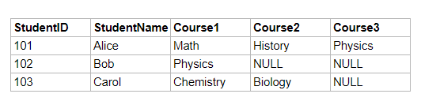Original "**StudentCourses**" Table:

Assignment Tasks:

1. Identify Normalization Issues:

List the normalization issues present in the "StudentCourses" table. Explain why these issues violate normalization rules.

1. Normalize the Table:  
   Create one or more normalized tables that represent the same data without the identified normalization issues.  
   Explain how you have transformed the original table to achieve normalization.

**Solution:**

1. Each column in the 1st Normalization form (1NF) should have a unique and clear name, but in the "StudentCourses" table, Course 1, Course 2, and Course 3 columns are repeating groups. To find the physics course, we must check three separate columns during the query, which violates normalization requirements. This is a 1NF issue.
2. Normalization of the above table:

**Student**  **Course**

|  |  |  |  |  |  |  |  |  |  |  |  |  |  |  |  |  |  |  |  |  |  |
| --- | --- | --- | --- | --- | --- | --- | --- | --- | --- | --- | --- | --- | --- | --- | --- | --- | --- | --- | --- | --- | --- |
| |  |  | | --- | --- | | **StudentID** | **StudentName** | | 101 | Alice | | 102 | Bob | | 103 | Carol | | |  |  | | --- | --- | | **CourseID** | **CourseName** | | 1 | Math | | 2 | Physics | | 3 | Chemistry | | 4 | Biology | | 5 | History | |

**StudentCourses**

|  |  |  |
| --- | --- | --- |
| **ID** | **StudentID** | **CourseID** |
| 1 | 101 | 1 |
| 2 | 101 | 5 |
| 3 | 101 | 2 |
| 4 | 102 | 2 |
| 5 | 103 | 3 |
| 6 | 103 | 4 |

Here, at first, I created two tables: “Student” and “Course”. Where **StudentID** is the primary key of the “Student” table and **CourseID** is the primary key of the “Course” table. Then I created the “StudentCourses” table, in which **StudentID** and **CourseID** are foreign keys. This is the child table of the parent tables, “Student” and “Course”.